Lab 8 Number Guess Game

Instructions
- Answer the below question in the boxes if needed.
- Code on your computer and zip all your code before submission.
- Please submit the assignment after you finish.

Part 1 Setting Up prompt-sync Library

1.1 Install the prompt-sync library
Steps:
- Download the code package from the materials folder
- Unzip the folder and open the folder in VSCode
- In VSCode, Click “View” -> “Terminal”, and try to type “npm” and press enter
- If there are no error from the previous step, then double check that you are in the assignment folder (Tips: you should be able to see the correct folder name in the command line)
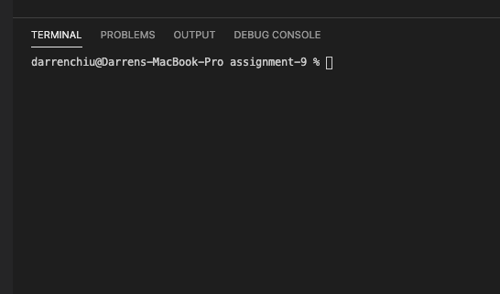
- Type the following command sequence one-by-one. There should be no error and show successfully installed
  - Run “npm init”
  - Keep pressing enter, until you see “Is this OK?”, then type y
  - One the initiation is done, run “npm install prompt-sync”

1.2 Test and make sure that prompt-sync is working
Steps:
- Reference the code below, and copy paste the piece of code that would ask users for an input to the “while” loop. (Tips: You don’t need to import the library again, as we have imported it for you)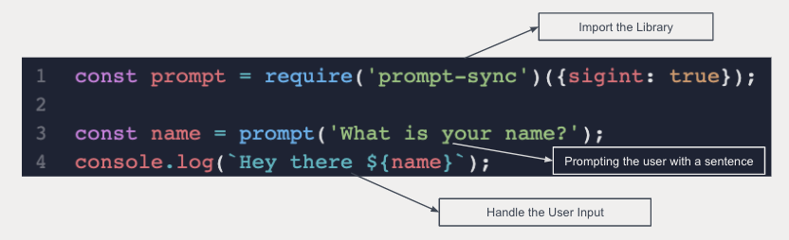
- Run your code and see if that works. The code should keep asking users for some input
(Note: To run code that would capture the user's input, we will need to run it by typing command in the terminal. Please switch to the “Terminal” at the bottom of VSCode, and type the following command for running the code. That’s why we need to learn terminal in Lecture 2)
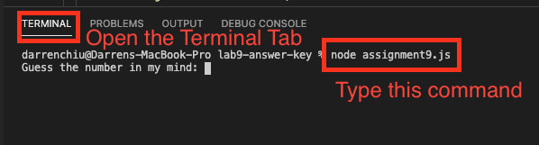
- If it is working, then move to Part 2.

Part 2 Setting Up prompt-sync Library

2.1 Implement the Number Guessing Game
Steps:
- There are 2 parts of the program in the while loop. Implement the two parts one by one.
- Detailed logic of the number guessing game (the first 2 is already done for you):
  - generate a number
  - keep asking user to “guess”
  - on each guess, tell the user if the number is too big or too small
  - if the “guess” is correct, then tell the user that they win.

2.2 Implement the bonus part (Optional)
Steps:
- Try to make some changes in the program so users can start a new game after finishing one game
- The program should ask the user if they want to start a new game after finishing a game. Users can enter “Y” or “N” to choose whether to start a new game or not.

